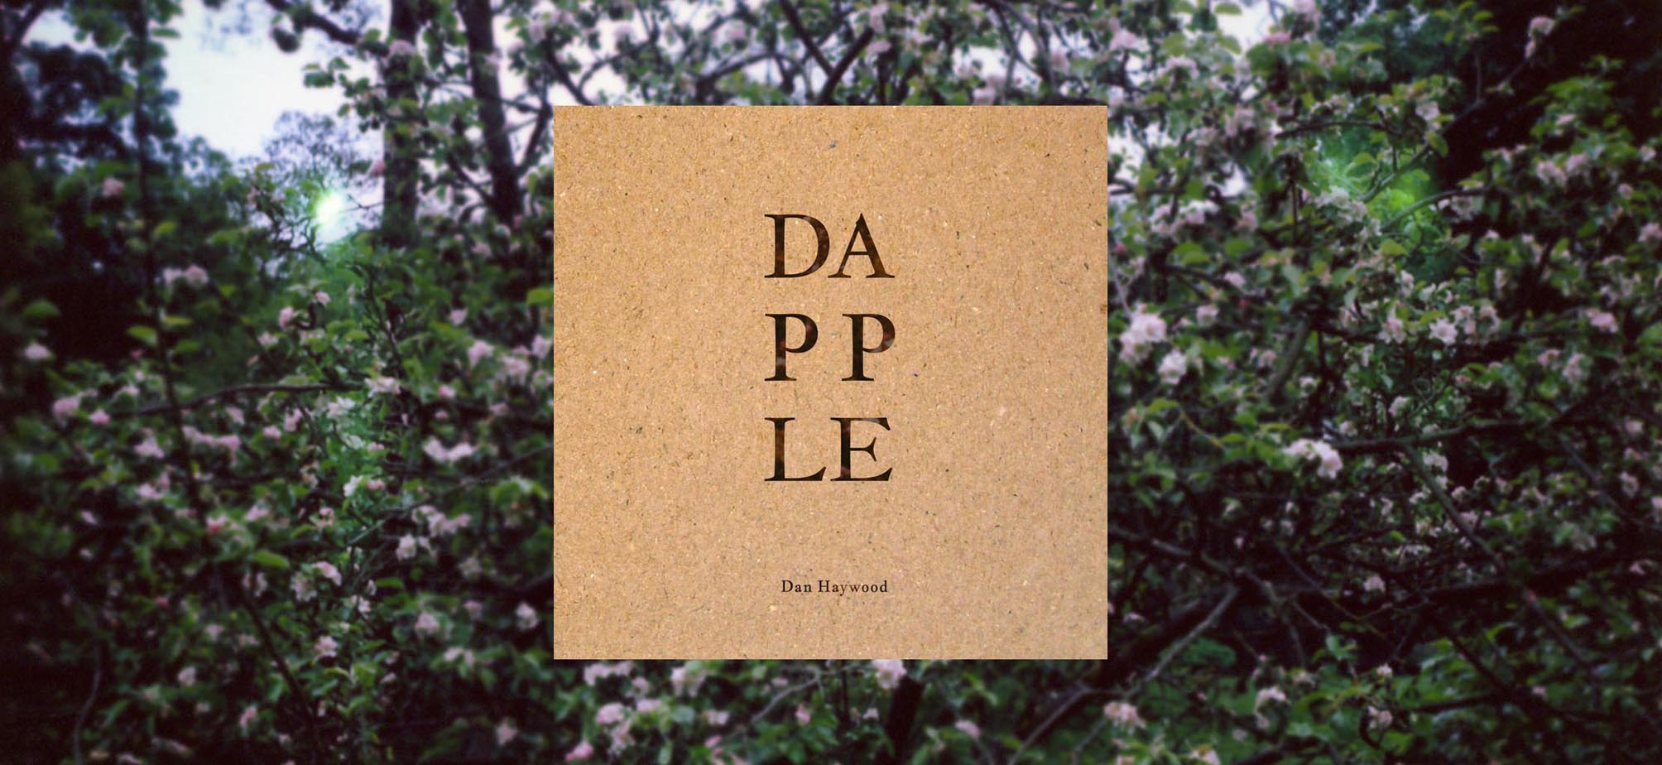

DAPPLE by DAN HAYWOOD

OUT 4 NOVEMBER 2013
ON SOUTHERN BIRD RECORDS

Private advance stream: http://snd.sc/12XjQQX

Private advance download: https://dl.dropboxusercontent.com/u/6139389/Dapple%20-%20Dan%20Haywood%20-%202013.zip

Watch the recording of “Suspicious Farms” here: http://www.youtube.com/watch?v=aj4gGO-ZxYA

Dan Haywood is a songwriter and ornithologist based in Lancashire, England, where Dapple was recorded at various locations in the Forest of Bowland. His reputation as a storyteller and performer of the highest distinction is gathering steam on the back of a string of choice shows with fellow sonic nomads including Josephine Foster, Michael Hurley and The Tallest Man on Earth.

“Given that Dapple could be set in the 18th century, I was keen for there to be no motor vehicle noise, just in case the listener might prefer to imagine it that way. So the locations had to be out of the way, and some of the sessions started as early as 4am to beat the sound of the Abbeystead gamekeepers’ Land Rovers and Bowland farmers’ tractors. Days on which the breeze might gust above 5mph were avoided, which was good for reducing wind noise and for a preponderance of midges.

In the spring sessions the air was alive with birdsong, and you’d wade into that set and make a small territory and start singing yourself, just a thread in a tapestry. There’s a list of avian background singers and scene-stealers on the sleeve. Later sessions could be deathly quiet and the molestation of the air was all our doing, like on the post-dusk title track, when the frightened words seemed to flash up in a pitch-black anechoic chamber. Rather than Milton’s darkness visible, it’s darkness audible.

I spent half a decade making a very long-playing record called Dan Haywood’s New Hawks, which was largely a place-specific and time-specific suite of songs, set in places in the Highlands of Scotland where I lived and worked in the early years of the 21st century. There were huge flights of fancy and trips around the globe, but it always returned there – a 32-part love song to Caithness and Sutherland. But as a suite, Dapple is a love letter to rural England, although it sometimes perhaps sounds a little Danish or Austrian or Hungarian.

New Hawks involved many musicians, and had a few snatches of library recordings of Highland birds and so forth. At the time, we were working in increasingly larger buildings like churches for spatial effects. So it seemed to be the next step to record in the outdoors and be part of the ambience rather than add that in. My New Hawks bandmate, the inimitable Mancunian composer and multi-instrumentalist Paddy Steer, had picked up a ’70s mono Nagra, a portable tape recorder used in film and radio, which audiophiles maintain is of the highest fidelity. I nagged him to help me with an al fresco project.

Obviously I needed players who could work fast and sound good, and who weren’t addicted to post-production or overdubbing – because none of that was available; it was all live and set in stone. So we have Mr Steer, Andy Raven, Therese Standish, Richard Turner and Jeff Barnes, who are tasty and fearless, and all necessarily unplugged – on guitars and mandolins but also double basses, drum kits and harmoniums that got heavier and heavier as we carried them up bilberry-covered hills or down ferny gullies.

Dapple eavesdrops on formative scenes in the life of its protagonist, giving fine detail or a strong scent and then flashing backwards or forwards to another point, inviting us to sketch out what happened in between. To join the dots, dot-to-dot. Musical vignettes and stockier songs. Did the previous episode inspire or defeat? Galvanise or slowly poison? Why, at 40, does the protagonist give less thought to his horse’s years of uncanny, near-human attentiveness than he does to a strange woman he glimpsed when he was 10?

The first song sees the young man sat in an orchard, where he meets his second love. He isn’t a working man. I was playing at the foot of a willow, and when a wren blasted in, I knew to pause for a bit. The wren has the loudest song on the record.

The second song is based on a Schubert favourite. Classical, but the folkiest tune. My lyrics rearrange an English-language version of the Christian Schubart poem that traditionally accompanies Schubert’s melody, which my mother used to sing to me as an infant. The take we used is solo (voice & guitar), and features a musical rest that coincides with a woodpecker drumming – a perfect fill, perfectly timed. It was the only point at which the woodpecker drummed that morning, so we had to use that take.

The next piece sounds like an old English country dance tune – a folky-classical guitar piece played in unison with Andy. It’s quite technical for me. I copped some of the fiddly bits from James Taylor. I always wanted to record something a bit like James Taylor. Though I’m sure JT would be horrified.

“Dapple” was recorded on a muggy evening, with night falling around us. It was just me and a big 12-string and Paddy and his reel-to-reel and by the time the best take came we could no longer see each other, or indeed anything. It’s a jarring, frozen song and the cover of darkness and the stillness of the air made conditions optimal. The character is fortyish and a drunkard in this one. He’s in possession of a horse called Dapple who does the walking for him. Rescues him. Often wakes up in the stables. He’s wealthy but lonely, dreaming of “real gold – true love”.

Then we have a dawn chorus.

“I’ve Got Heaven at My Door” is akin to a hymn or a prayer. We sat on a stony island in the river Wyre at Abbeystead and recorded it as the birdsong and the rising temperature made it worth having got up in the middle of the night. The sort of heaven I had written about. It’s pantheistic but also asks Jesus, “Am I your baby too?”. The character steps into a natural paradise in times of grave doubt. It’s almost like an English gospel tune, with the sound of the rapids and the repetition of the words having a hypnotic effect.

In the next song, the protagonist and his third love are confronted by a paranoid farmer. But once the shotgun barrel drops, so does the farmer’s guard, and we hear his sad tale. The lush farm is his prison. Throughout the suite these places of beauty turn from heaven to hell and back again. Therese and her harmonium and my guitar and I were sat under a lone oak in full leaf, with bilberry understory and a dry stone wall. It gave a new freedom to recording to be scanning along a moorland vista as we played. We could see for miles rather than being constrained by the four walls of a studio. The red-light fever dissipated and we opened up, and that’s why it’s an honest rendition.

The last song, “Made for the May”, has a melody I like. Structurally it reminds me of mid-period Byrds – perhaps a lost Crosby-McGuinn composition from Younger Than Yesterday. It even has a 12-string on it. And it has a similarly stately pace to their Hiroshima ballad “I Come and Stand at Every Door”.
”

---

Tracklisting

1 The Apple Tree
2 A Trout
3 A Floral Dance
4 Dapple
5 I’ve Got Heaven at My Door
6 Suspicious Farms
7 In the Willows
8 A Floral Dance (Reprise)
9 Lapping Wave
10 Made for the May

---

Catalogue SBR001
Barcode 5060174956188
Release 4 November 2013
Format CD, digital
Territories UK, limited US/EU in territories tbd

Artist danhaywood.net
facebook.com/groups/24026288605
twitter.com/dhnewhawks

Label Southern Bird Records
www.southernbird.com
emily@southernbird.com

Distribution Cargo
www.cargorecords.co.uk
darren@cargorecords.co.uk

Publicity Mutante Inc
www.mutante.co.uk
sean@mutante-inc.demon.co.uk

Press niche press.danhaywood.net

Booking Qu Junktions
www.qujunktions.com
john.qujunktions@gmail.com

Management Southern Bird
www.southernbird.com
emily@southernbird.com

---

Praise for Dan Haywood’s New Hawks:

“This strong, 32-song album is positively livid with ideas and resists easy categorisation”—WIRE MAGAZINE

“A wild-eyed mix of cosmic country and chamber-folk...makes for a thrilling noise”—UNCUT MAGAZINE

“Charmingly, it succeeds in being both engaging and oddly uplifting while also being as dour in texture as a North Sea shoreline”—INDEPENDENT ON SUNDAY

“A grand, definitive statement... sacrificing none of his unique poetic elegance for the sake of either conformity or convention”—THE LINE OF BEST FIT

“Defiantly individual... Surely a future cult classic, its raw takes on folk and country are a timeless delight”—24/7

“A lifework in its extensive meditations”—SHINDIG MAGAZINE

“Epic... fervent and profound”—THE FLY

